Grade 9 French Immersion Supply List 2022-2023

- 1- 2 Binders (How many you decide to purchase will depend on how your child decides to organize their binder, will need to include 7 core subjects and 3 specialty courses)
- Lined paper (2 packs of 250 sheets)
- Graph paper (1 small package)
- 4 (or more) Hilroy Exercise scribblers (32 pages - for math)
- Binder dividers – 10
- 4 duo-tangs (Blue, Red, Yellow and Green)
- Pens
- Pencils (48 minimum)
- Highlighters (4 of any colour)
- Ruler
- Erasers (2-4)
- Glue sticks (2)
- Scissors
- Pencil sharpener
- Pencil case
- 1 pkg colored pencils (a must!)
- 1 Protractor ( 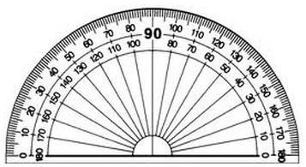 individual ones can be found at staples to avoid buying an entire math set)
- 1 Scientific calculator (very important) ***cannot use their phones as a calculator

PHYSICAL EDUCATION
- Shorts and comfortable clothing

Grade 9 BAND
- Instrument with cleaning kit
- 1” Black binder
- Pencil

Grade 9 Art

- 24 2HB Pencils
- 2 erasers
- 15cm ruler
- 12 coloured pencils
- 2 regular black sharpies
- 2 glue sticks
- 2 black pens
- 1 package of white paper

