Madeline Symonds Middle School
Phone: (902) 832-2300 https://msm.hrce.ca/
Fax: (902) 832-2302 E-Mail: msms@hrce.ca
Twitter: @madelinesymonds December 2019

Important Dates
December 20 - Last Day before winter break
January 6 - Classes resume

If there are any days your child is not attending school or will be late please call the office at 832-2300 to let us know so that we know your child is absent with permission and that the absent days are recorded as “excused” on the PowerSchool attendance records.

PRINCIPAL’S MESSAGE

It’s hard to believe that December is here already!! We enjoyed nice weather until mid November so we can’t complain too much! Now that winter has arrived we remind all students to dress appropriately and encourage them to bring a hoodie or sweatshirt to wear at school as the temperature in each room can fluctuate greatly. Please do what you can to convince your child to wear seasonal clothing and we appreciate your support!
For your convenience we’ve included the guidelines for school and bus cancellations and would strongly recommend signing up for the early morning alerts that are sent to you via the HRCE.
Parent Teacher Interviews:
Thank you to all parents and guardians for attending our evening and afternoon sessions of Parent Teacher Interviews! Neither freezing rain, nor snow, nor dark of night kept you from attending and we know many of you had an extremely long ride home so we greatly appreciate your attendance. We hope you were pleased overall with the academic success demonstrated by the students and we appreciate your support in teaming to make your child as successful as they can be. If you have any concerns please establish communication with the teacher and I am available to assist you at the office if you need me.
Housekeeping:
All parents / guardians are reminded to provide a written note or email to either michelle.oconnor@hrce.ca or morriss@hrce.ca or fax (902) 832-2302 to the office if giving permission for your child to be picked up by someone other than the designated parent/ guardian.
Stock transportation also requires a note from a parent if wishing for a student to travel on the bus to another student's house. If the busses are full, it is not always possible but Stock will accommodate whenever they can.
Parents and guardians are asked to please contact the school with a signed written note, email or fax if allowing student to leave school without being available to sign them out.
Also, all visitors to the school are to report directly to the school office to sign in. This process is mandatory as a means of tracking our school population for safety purposes so your cooperation in this matter is greatly appreciated!
We have noticed that there has been an increase in the number of students coming late to school and want you to know that school is in session and work will continue right up until the 19 as some classes are celebrating the holidays on the 20th with movies, food , etc.
Holiday Music Celebration
In closing, on behalf of the staff and students of Madeline Symonds Middle School, we wish you all a safe, festive Christmas, Kwanzaa, Hanukkah, and Happy Holiday season with loved ones and a very Happy New Year!!!
Respectfully,
Kim Acorn

Celebrating Our Students

Madeline Symonds Middle School is pleased to announce that 185 students, or 25% of our student population, have been awarded perfect attendance for the month of November. We would like to congratulate them on their accomplishment. Well done !!!!

Yearbook Committee

Looking to hold onto moments from the 2019-2020 school year at Madeline Symonds Middle School? Looking to snag a great deal? Look no further! The yearbook's 'Early Bird' special is on SALE starting Monday, December 2nd!

CLICK HERE to what option is available to you!
Job/Order Number: 21477

Yearbook FAQs:

When can I purchase a yearbook at the early bird special pricing?
You can take advantage of the 'Early Bird' yearbook special of just $35.00 starting on Monday, December 2nd, ending on Friday, December 20th.

Where can I purchase a yearbook?
You can purchase yearbooks online using the link above; alternatively, students can purchase yearbooks during their lunch break outside of the cafeteria by cash or by cheque made out to Madeline Symonds Middle School during the dates listed.

How much will it be if I miss the deadline for the special pricing?
Yearbooks at the regular price of $40.00, will be on sale one more time just before March Break, stay tuned to the school newsletter for more updates.

When will I receive my yearbook order?
Yearbooks will be bundled by homeroom, with the recipient names inside, and given to homeroom teachers to deliver at their discretion. The distribution date for students is tentatively set for the afternoon of Monday, June 15th, 2020. Stay tuned to the school newsletter for more updates.

- Yearbook Committee 2019-2020
MSMS School Dance

Thursday, January 16, 2020
6:30p.m. - 8:30p.m.
$6.00 or $5.00 with a non-perishable food donation to the Food Bank
Only students from MSMS are permitted to attend the dance. It is for all MSMS students in grades 6, 7, 8 and 9.
Tickets will go on sale during lunch times starting Monday, January 13 through to Thursday, January 16.
Hope to see you there!

Sports
Track and Field dates 2020

Tryouts will be in mid April
County Meet May 19-20
Regionals May 27-28
Rain Date May 29th
Provincials- June 5-6th (Northumberland Region)

**Students and parents are asked to view the "Athletics" webpage on our MSMS website for any school sport information.

MSMS WEDAY Initiative

Our We Day committee ran a collection of hats mittens and socks for homeless shelters across Halifax. Thank you for your contributions to this campaign.

Beaver Math Computation Challenge
MSMS had the opportunities to take part in the Beaver Computation Math Challenge held here at our school over a two week period in November. This challenge was offered to grade 6, 7, 8, and 9 students. Students had 45 minutes to complete a series of multiple choice questions to develop students’ problem solving skills from a variety of concepts, increasing in difficulties..
MSMS saw 17 Grade 6 students take part. The Grade 6 challenge was out of 60. Our top 3 students in grade 6 were Jeremy Doane (56); Peyton Binder (55) and Sarah Deagle (54). Grade 7/8 saw 57 students take part. The grade 7/8 challenge was out of 90. Our top 3 students for this grouping were Kate Bussey with a perfect mark of 90; Sherry Chen and Nicholas McIntyre both received 82. (These six students also had their names published in the - Beaver Computational Math Challenge results.)
Our Grade 9s had 16 students take part. The grade 9 challenge was also out of 90. Our top 3 students for this grouping were Han Zhou (80) and Kyra Maritz and Colin Roberts both receiving 76.
Congratulations to all other students who made a fantastic effort with these questions!
If you are interested in looking at the type of questions used in this contest for all grades, you may find them by visiting University of Waterloo- Beaver contest at the following website: www.cemc.uwaterloo.ca/contests/gauss.html. These are great to practice and use as a challenge.
Keep an ear out for the next Math Challenge that MSMS will take part in!
MSMS Student of the Month
This program is to recognize students who display leadership in demonstrating respect for self, others, learning and environment. As well as no office referrals, has outstanding attendance and all work is up-to-date.
Homeroom | November
601 | Dominique Frith
602 | Ben  Walker
603 | Gabe Thompson
604 | Naina  Sudharsan
605 | Anna Kennedy
701 | Thomas Connell
702 | Kayleigh Grant
703 | Rachel Walsh
704 | Jensen Veinotte
705 | Leo Kanso
706 | Ethan Reid
707 | Rowan Aucoin
708 | Alex Warnica
709 | Lazarus Joseph
801 | Ethan Nelson
802 | Nick Mooney
803 | Matthew McCarron
804 | Jennica Dowell
805 | Lisa Snow
806 | Kate Bussey
807 | Gracie Reid
808 | Ciara Van der Put
901 | Nad Zhdanov
902 | Audra Robinson
903 | Emily Jensen
904 | Kate Byrne
905 | Tate Kieser
906 | Marshall Hebb
907 | William Reichheld
From the Guidance Office
Parents/Guardians of Grade 9 students…
In the new year, we will be working together to choose your child’s courses for grade 10. Important dates will be sent home in January regarding information sessions, timelines and presentations. Please ensure you save these dates when they are made available to you. All grade 9 parents and students NEED to be able to access PowerSchool. Please DO NOT wait until the last minute to ensure you are able to access your child’s PowerSchool. I encourage you to contact your child’s homeroom teacher this week if you do not have this information. You will not be able to complete the registration process without this information. As the registration process takes place, please feel free to reach out to me if you have questions or concerns.

Judi Hutchison
MSMS School Counsellor
jhutchison@hrce.ca
902-832-2300 ext. 2
Grade 9 Trip
The dates for the grade 9 trip have been confirmed, June 9-11, 2020. Please keep checking the school website for updates and fundraising events. There is currently the grocery store gift card fundraiser taking place, tickets are due back to Mrs. Bolivar by Dec. 10th as the draw takes place on Dec. 13th.. Thank you to the parent volunteers that have stepped up to run the fundraising.

There is an up to date itinerary on the school website under Grade 9 Trip. The tour company has provided the total cost of the trip per student to be $465. Remember you can only fundraise up to the cost of the trip, all other money will go in the general trip funds.

The next payment of $100 is due by Jan. 10th. Fundraised amounts can go towards covering this payment. You may also pay your balance in full if you would like, $465 -$100 deposit - remaining balance $365.

If you have any questions please feel free to contact Mrs. Bolivar at wbolivar@hrce.ca.
SLAC
Student Life Activity Council

Here are a list of activities hosted by SLAC for the month of December:
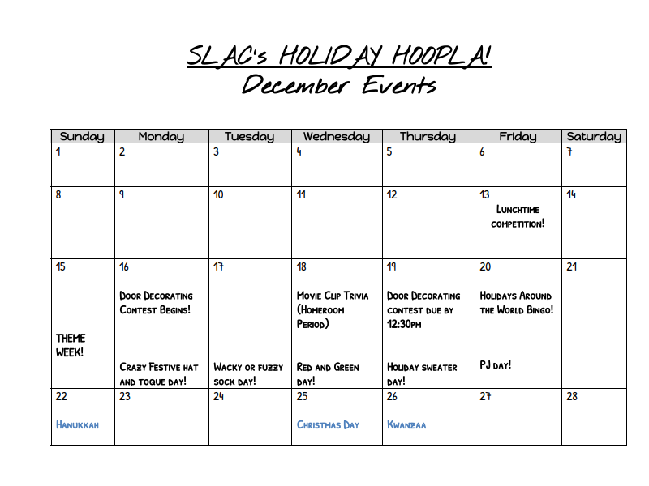
Breakfast Program

Thank you to Ben Jessome for his continued support of our breakfast program.

